- Repository (Ma’lumotlar Ombori) yaratish
- Buyurtmalarni saqlash uchun OrderRepository sinfini yarating.
- Buyurtmalarni saqlash, qidirish, va ro‘yxatni chiqarish metodlarini yozing.

Repository (Ma’lumotlar Ombori)
1.Repository nima?
Repository — bu ma’lumotlarni saqlash va ularga kirish uchun mo‘ljallangan oraliq qatlam bo‘lib, dasturiy ta'minotda ma’lumotlar manbai (odatda bazalar, fayllar yoki xotira) bilan ishlashni soddalashtiradi.
- Repository’ning asosiy vazifasi:
Ma’lumotlarni saqlash (add)
Ma’lumotlarni olish / qidirish (get)
Ma’lumotlar ro‘yxatini chiqarish (list)
Dastur logikasini va ma’lumotlar bazasi logikasini ajratib turadi

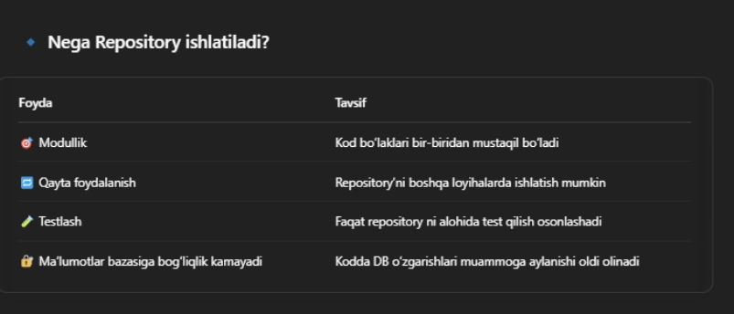

main.py

from order_repository import OrderRepository

repo = OrderRepository()

# Buyurtma qo'shish
repo.add_order("Firdavs", "Noutbuk", 2)
repo.add_order("Faxriddinov", "Monitor", 1)

# Bitta buyurtmani ID orqali olish
order = repo.get_order_by_id(1)
print("Order ID 1:", order)

# Barcha buyurtmalar ro'yxati
orders = repo.list_orders()
print("All Orders:")
for o in orders:
print(o)

order_repository.py

import sqlite3

class OrderRepository:
def __init__(self, db_name='orders.db'):
self.db_name = db_name
self._create_table()

def _connect(self):
return sqlite3.connect(self.db_name)

def _create_table(self):
conn = self._connect()
cursor = conn.cursor()
cursor.execute('''
CREATE TABLE IF NOT EXISTS orders (
id INTEGER PRIMARY KEY AUTOINCREMENT,
customer_name TEXT NOT NULL,
product TEXT NOT NULL,
quantity INTEGER NOT NULL
)
''')
conn.commit()
conn.close()

def add_order(self, customer_name, product, quantity):
conn = self._connect()
cursor = conn.cursor()
cursor.execute('''
INSERT INTO orders (customer_name, product, quantity)
VALUES (?, ?, ?)
''', (customer_name, product, quantity))
conn.commit()
conn.close()

def get_order_by_id(self, order_id):
conn = self._connect()
cursor = conn.cursor()
cursor.execute('SELECT * FROM orders WHERE id = ?', (order_id,))
result = cursor.fetchone()
conn.close()
return result

def list_orders(self):
conn = self._connect()
cursor = conn.cursor()
cursor.execute('SELECT * FROM orders')
results = cursor.fetchall()
conn.close()
return results

